JS_01:

<!DOCTYPE html>

<html lang="en">

<head>

<meta charset="UTF-8">

<meta name="viewport" content="width=device-width, initial-scale=1.0">

<meta http-equiv="X-UA-Compatible" content="ie=edge">

<title>JS01</title>

<script src="https://ajax.aspnetcdn.com/ajax/jQuery/jquery-3.3.1.min.js"></script>

<script>

$(document).ready(function(){

var d = new Date();

var days = ["Sunday", "Monday", "Tuesday", "Wednesday", "Thursday", "Friday", "Saturday"];

document.getElementById("Stoday").innerHTML = days[d.getDay()];

document.getElementById("hours").innerHTML = d.toLocaleString('en-US', { hour: 'numeric', hour12: true });

document.getElementById("mins").innerHTML = d.getMinutes();

document.getElementById("secs").innerHTML = d.getSeconds();

});

</script>

</head>

<body>

<main>

<p>Today is: <span id="Stoday"></span>. </p>

<p>Current time is: <span id="hours"></span> : <span id="mins"></span> : <span id="secs"></span> </p>

</main>

</body>

</html>

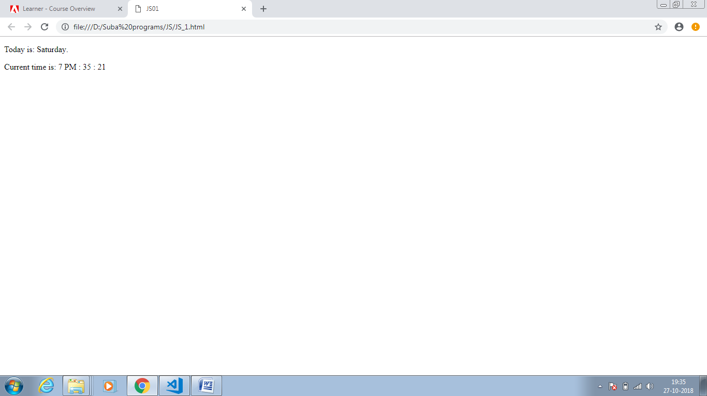

Js_02:

<!DOCTYPE html>

<html lang="en">

<head>

<meta charset="UTF-8">

<meta name="viewport" content="width=device-width, initial-scale=1.0">

<meta http-equiv="X-UA-Compatible" content="ie=edge">

<title>Document</title>

</head>

<body>

<p>Print content : <button id="printbutton">Print</button></p>

<script>

var Printer = document.getElementById("printbutton");

function Print()

{

window.print();

}

Printer.addEventListener("click",Print);

</script>

</body>

</html>

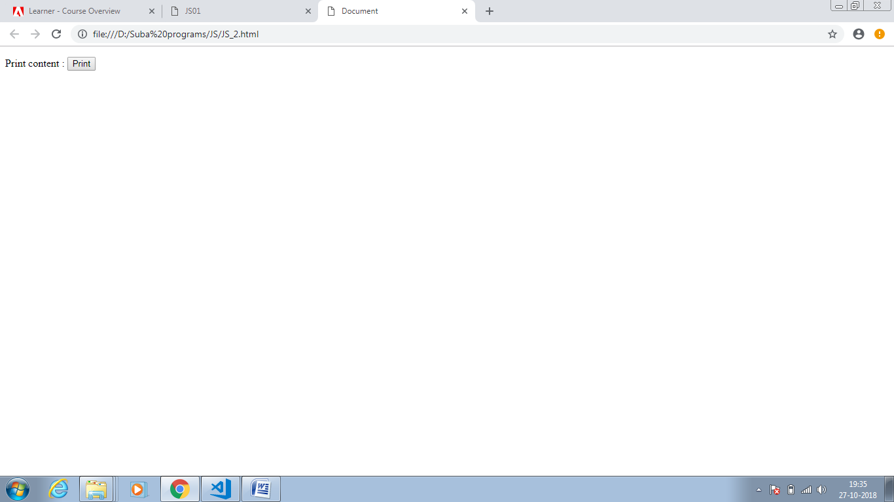

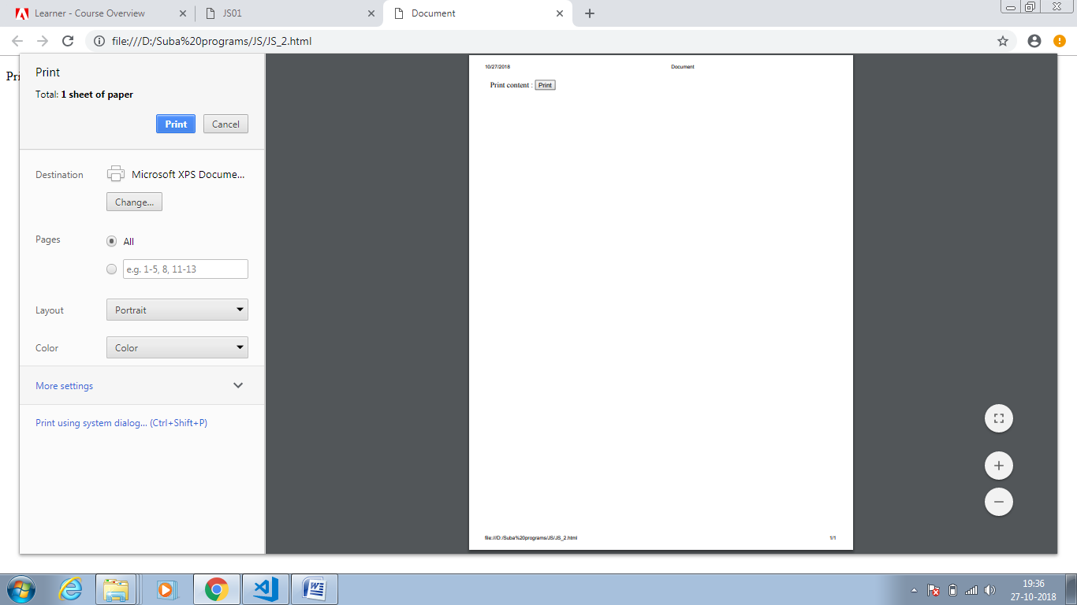

JS_03:

<!DOCTYPE html>

<html lang="en">

<head>

<meta charset="UTF-8">

<meta name="viewport" content="width=device-width, initial-scale=1.0">

<meta http-equiv="X-UA-Compatible" content="ie=edge">

<title>Document</title>

</head>

<body>

Current Date : <span id="formatDate1"></span> , <span id="formatDate2"></span>

</body>

</html>

<script>

var d = new Date();

var format1 = (d.getMonth() + 1) + '-' + d.getDate() + '-' + d.getFullYear();

var format2 = (d.getMonth() + 1) + '/' + d.getDate() + '/' + d.getFullYear();

document.getElementById("formatDate1").innerHTML = format1;

document.getElementById("formatDate2").innerHTML = format2;

</script>

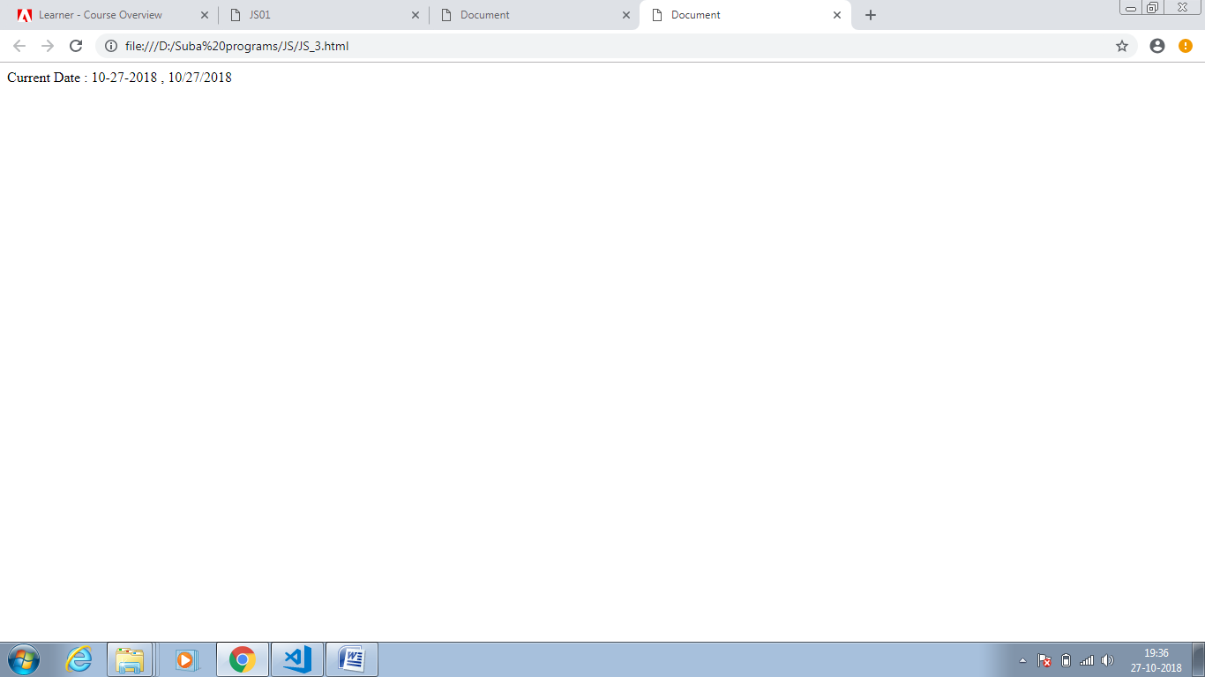

JS_04:

<!DOCTYPE html>

<html lang="en">

<head>

<meta charset="UTF-8">

<meta name="viewport" content="width=device-width, initial-scale=1.0">

<meta http-equiv="X-UA-Compatible" content="ie=edge">

<title>Document</title>

</head>

<body>

Enter Number: <input id = "txtnumber" type="text"/>

<button id="btnSubmit">Submit</button> <span id="message"></span>

</body>

</html>

<script>

function randomnumber(Maxvalue){

return Math.floor(Math.random() * Maxvalue);

}

var buttonclick = document.getElementById("btnSubmit");

buttonclick.addEventListener("click",Comparevalue);

function Comparevalue()

{

var inputnumber = document.getElementById("txtnumber").value;

var randomvalue = randomnumber(10);

if(parseInt(inputnumber) === parseInt(randomvalue))

{

document.getElementById("message").innerHTML = "Good Work";

}

else

{

document.getElementById("message").innerHTML = "Not matched";

}

}

</script>

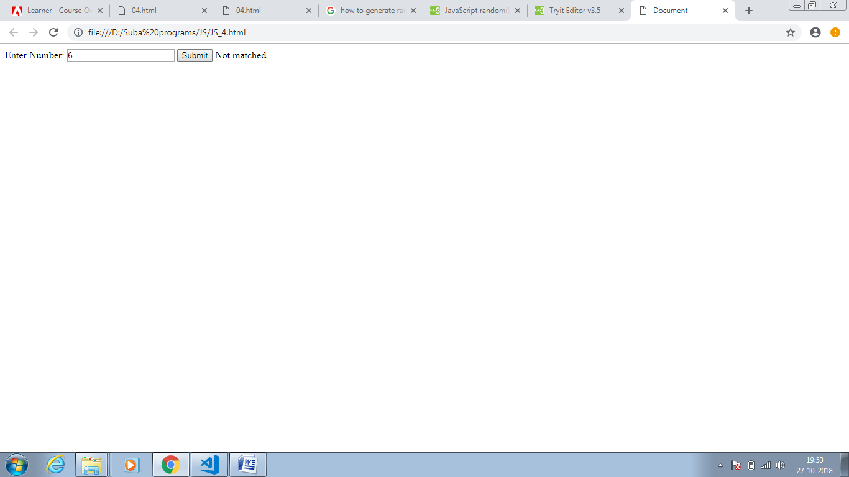

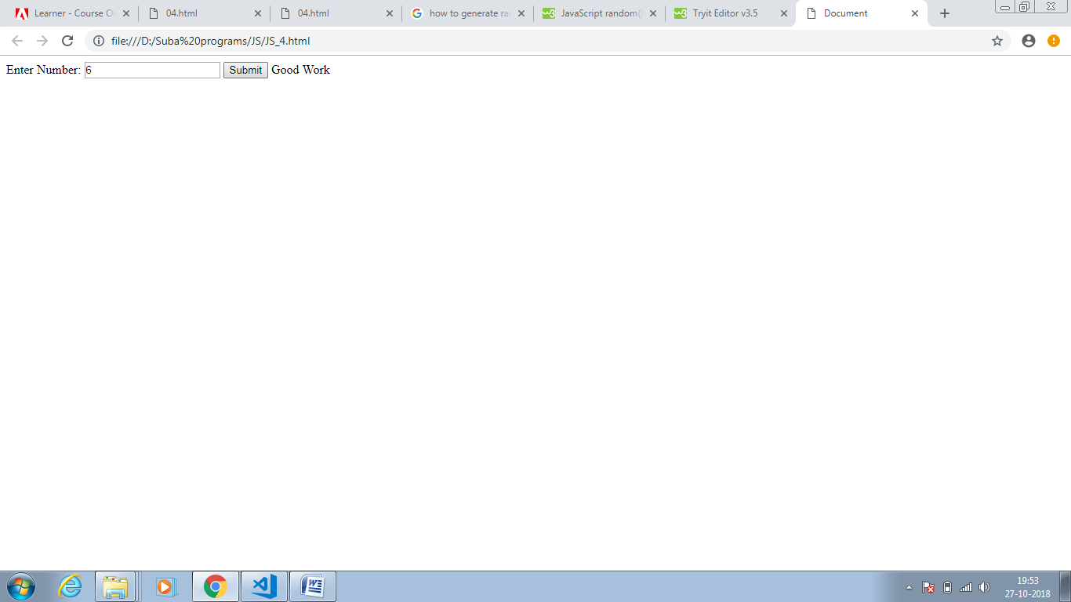

JS_05:

<!DOCTYPE html>

<html lang="en">

<head>

<meta charset="UTF-8">

<meta name="viewport" content="width=device-width, initial-scale=1.0">

<meta http-equiv="X-UA-Compatible" content="ie=edge">

<title>Document</title>

</head>

<body>

<p>1st Number : <input id= "Number1" type="number"/></p>

<p>2nd Number : <input id= "Number2" type="number"/></p>

<button id="btn1" onclick="Multiply()">Multiply</button> <button id="btn2" onclick="Divide()">Divide</button>

<p>The Result is :</p>

<span id="Result"></span>

</body>

</html>

<script>

function Multiply(){

var num1 = document.getElementById("Number1").value;

var num2 = document.getElementById("Number2").value;

document.getElementById("Result").innerHTML = num1 * num2;

}

function Divide(){

var num1 = document.getElementById("Number1").value;

var num2 = document.getElementById("Number2").value;

document.getElementById("Result").innerHTML = num1 / num2;

}

</script>

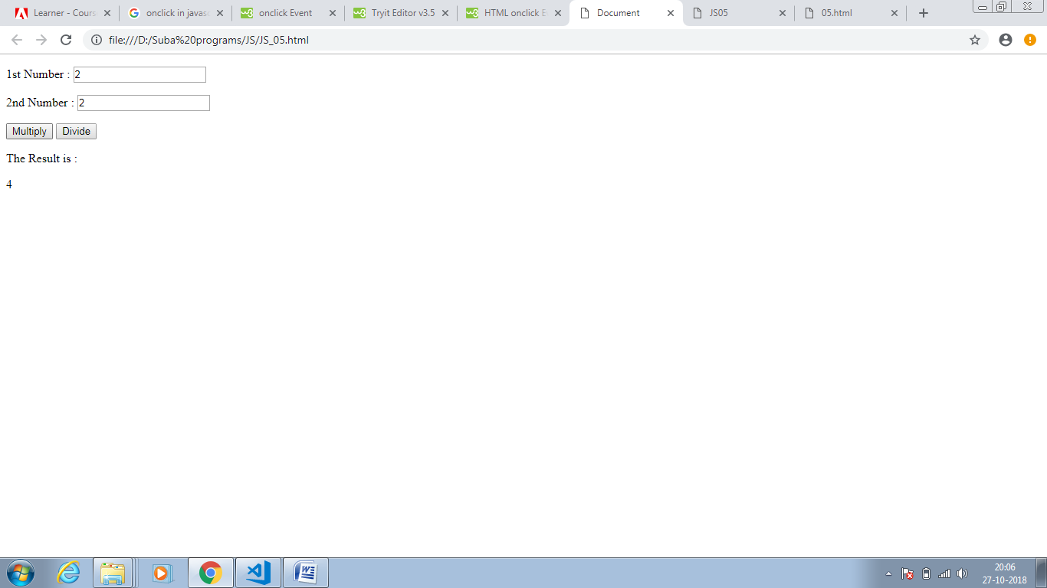

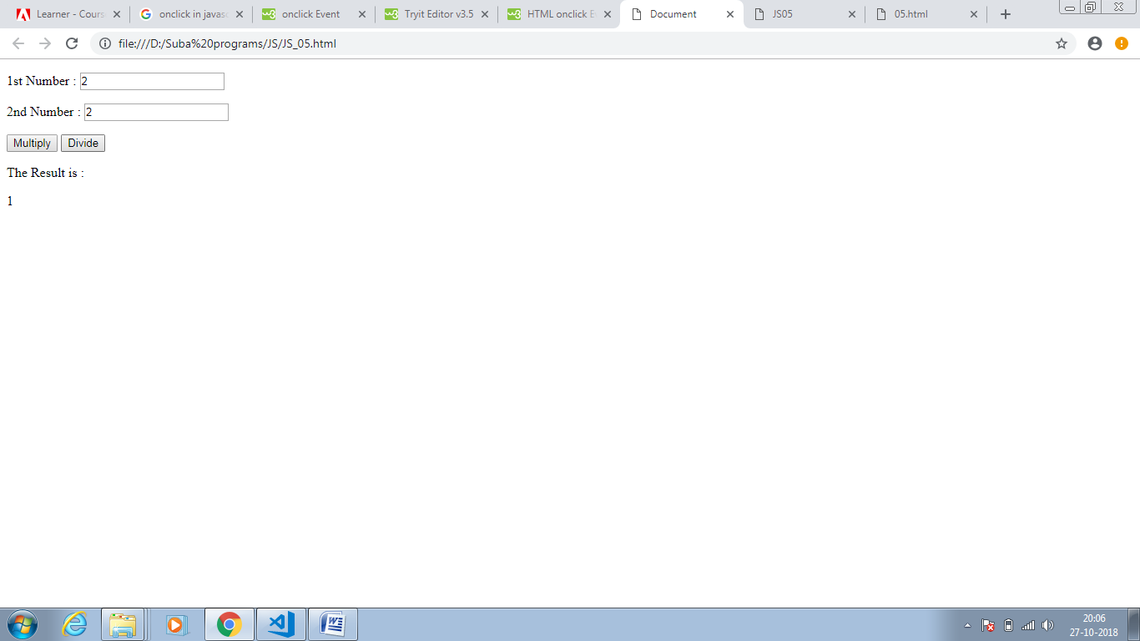

JS_06:

<!DOCTYPE html>

<html lang="en">

<head>

<meta charset="UTF-8">

<meta name="viewport" content="width=device-width, initial-scale=1.0">

<meta http-equiv="X-UA-Compatible" content="ie=edge">

<title>Document</title>

</head>

<body>

<script>

document.write(document.URL);

</script>

</body>

</html>

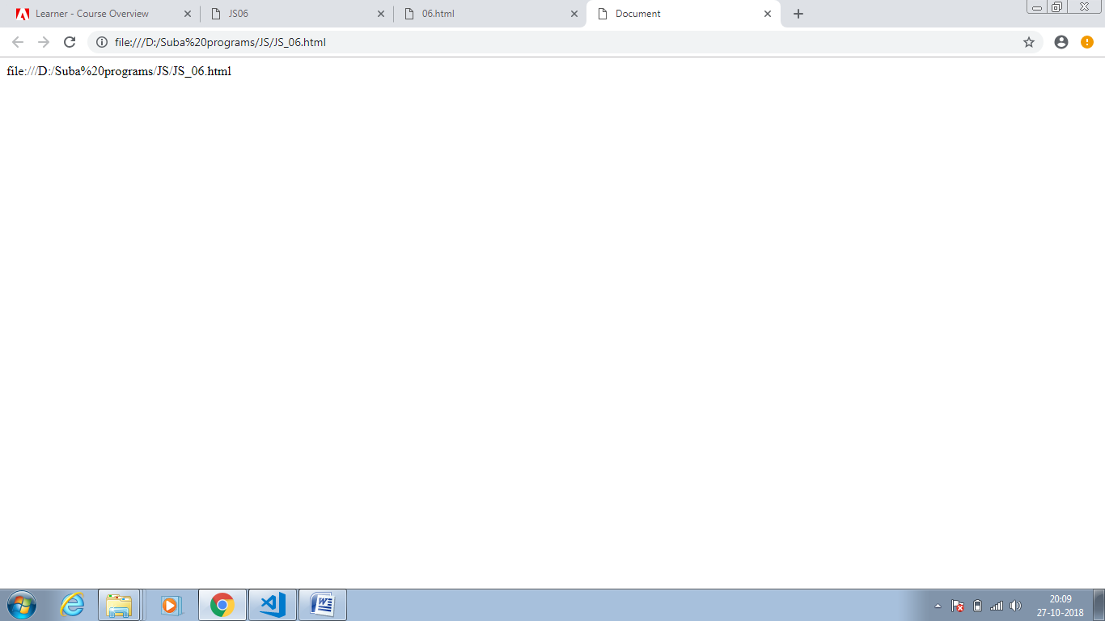

JS_07:

<!DOCTYPE html>

<html lang="en">

<head>

<meta charset="UTF-8">

<meta name="viewport" content="width=device-width, initial-scale=1.0">

<meta http-equiv="X-UA-Compatible" content="ie=edge">

<title>Document</title>

</head>

<body>

Enter Text: <input id = "txtstring" type="text"/>

<button id="btnSubmit" onclick="ToUpperCase()">Submit</button>

<span id="Result"></span>

</body>

</html>

<script>

function ToUpperCase()

{

var input = document.getElementById("txtstring").value;

var splitvalue = input.split(" ");

var length = splitvalue.length;

for(var i=0;i<length;i++ )

{

splitvalue[i] = splitvalue[i][0].toUpperCase() + splitvalue[i].substr(1);

}

var Result = splitvalue.join(" ");

document.getElementById("Result").innerHTML = Result;

}

</script>

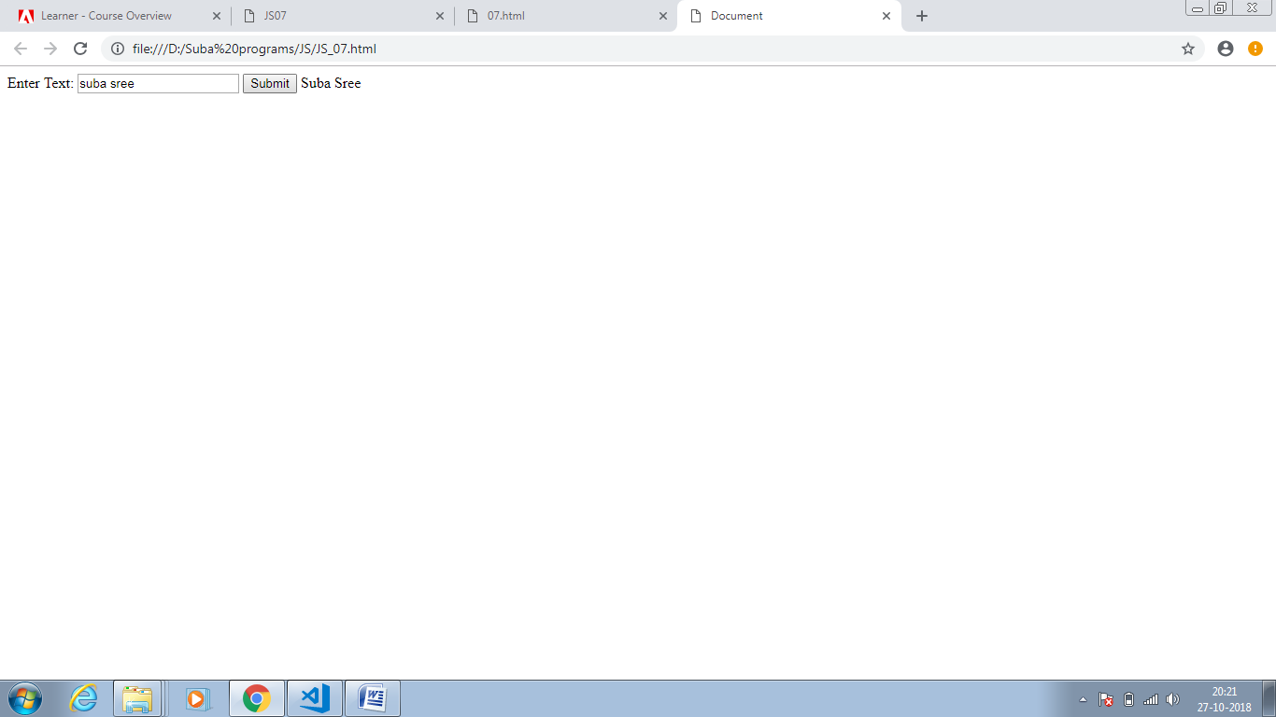

JS_08:

<!DOCTYPE html>

<html lang="en">

<head>

<meta charset="UTF-8">

<meta name="viewport" content="width=device-width, initial-scale=1.0">

<meta http-equiv="X-UA-Compatible" content="ie=edge">

<title>Document</title>

</head>

<body>

Enter Text: <input id = "txtstring" type="text"/>

<button id="btnSubmit" onclick="CompareString()">Submit</button>

<span id="Result"></span>

</body>

</html>

<script>

function CompareString()

{

var inpt = document.getElementById("txtstring").value;

var pvalue = inpt.replace(/[^p]/g,"");

var svalue = inpt.replace(/[^s]/g,"");

if(pvalue.length == svalue.length)

{

document.getElementById("Result").innerHTML = "true";

}

else{

document.getElementById("Result").innerHTML = "false";

}

}

</script>

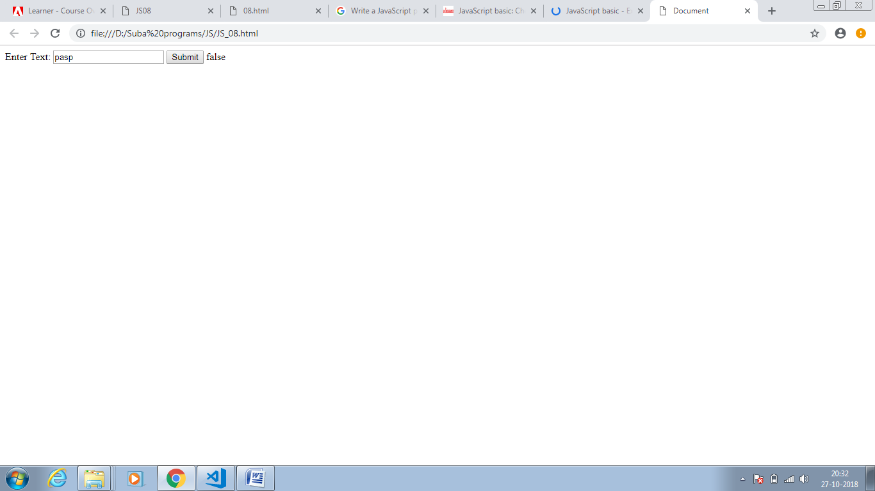

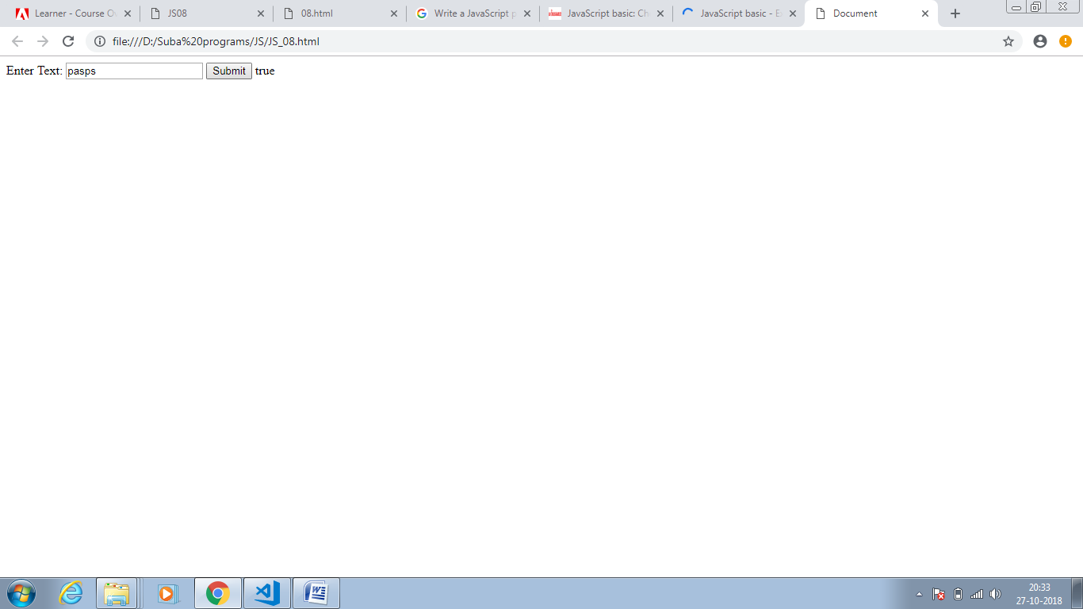

JS_09:

<!DOCTYPE html>

<html lang="en">

<head>

<meta charset="UTF-8">

<meta name="viewport" content="width=device-width, initial-scale=1.0">

<meta http-equiv="X-UA-Compatible" content="ie=edge">

<title>Document</title>

</head>

<body>

Enter Text: <input id = "txtstring" type="text"/>

<button id="btnSubmit" onclick="CompareString()">Submit</button>

<span id="Result"></span>

</body>

</html>

<script>

function CompareString()

{

var inpt = document.getElementById("txtstring").value;

if(inpt.length >= 3)

{

var result = inpt.substring(inpt.length - 3);

document.getElementById("Result").innerHTML = result+result+result;

}

else{

document.getElementById("Result").innerHTML = "false";

}

}

</script>

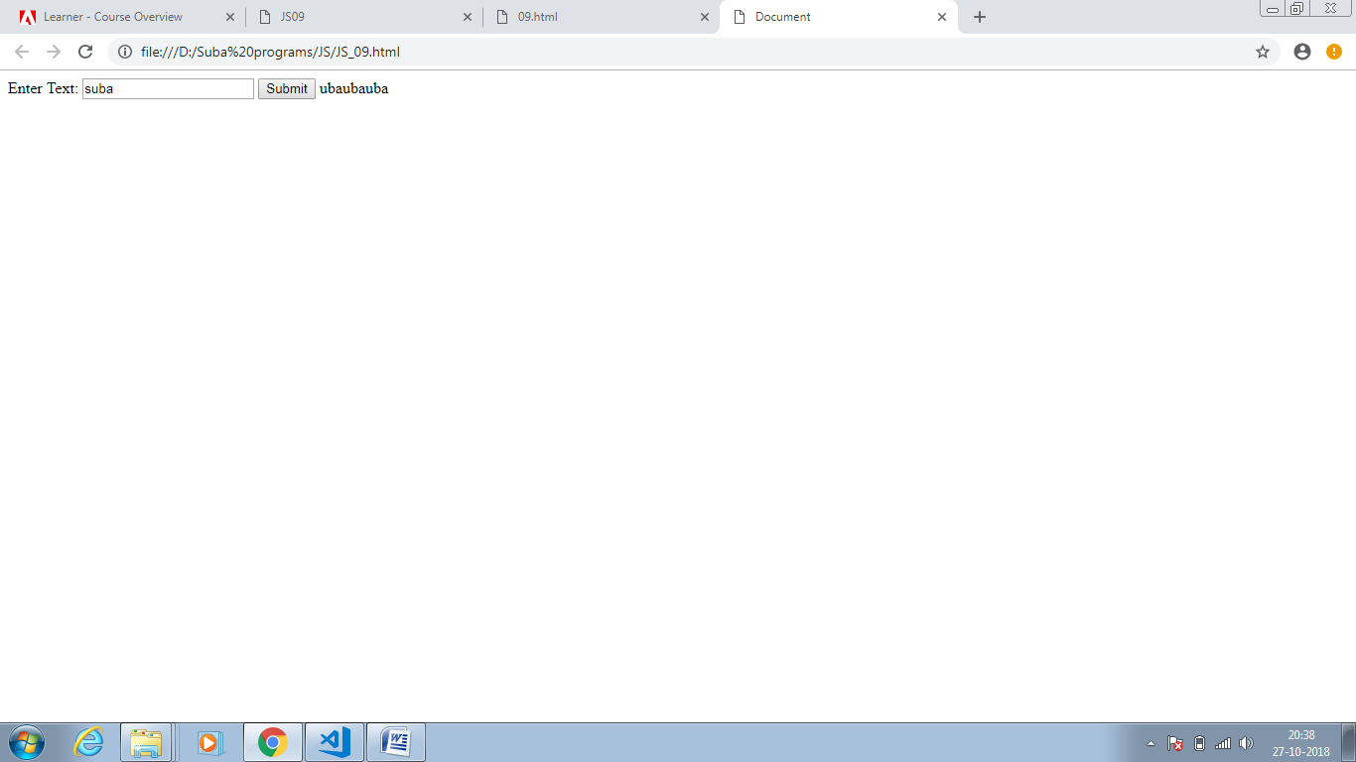

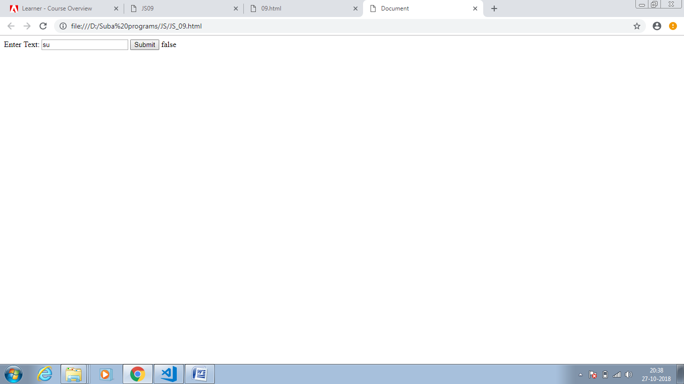

JS_10:

<!DOCTYPE html>

<html lang="en">

<head>

<meta charset="UTF-8">

<meta name="viewport" content="width=device-width, initial-scale=1.0">

<meta http-equiv="X-UA-Compatible" content="ie=edge">

<title>Document</title>

</head>

<body>

Enter Text: <input id = "txtstring" type="text"/>

<button id="btnSubmit" onclick="CompareString()">Submit</button>

<span id="Result"></span>

</body>

</html>

<script>

function CompareString()

{

var inpt = document.getElementById("txtstring").value;

if(inpt.length >= 1)

{

var result = inpt.substring(1,inpt.length - 1);

document.getElementById("Result").innerHTML = inpt.substring(inpt.length - 1)+result+inpt.charAt(0);

}

else{

document.getElementById("Result").innerHTML = "false";

}

}

</script>

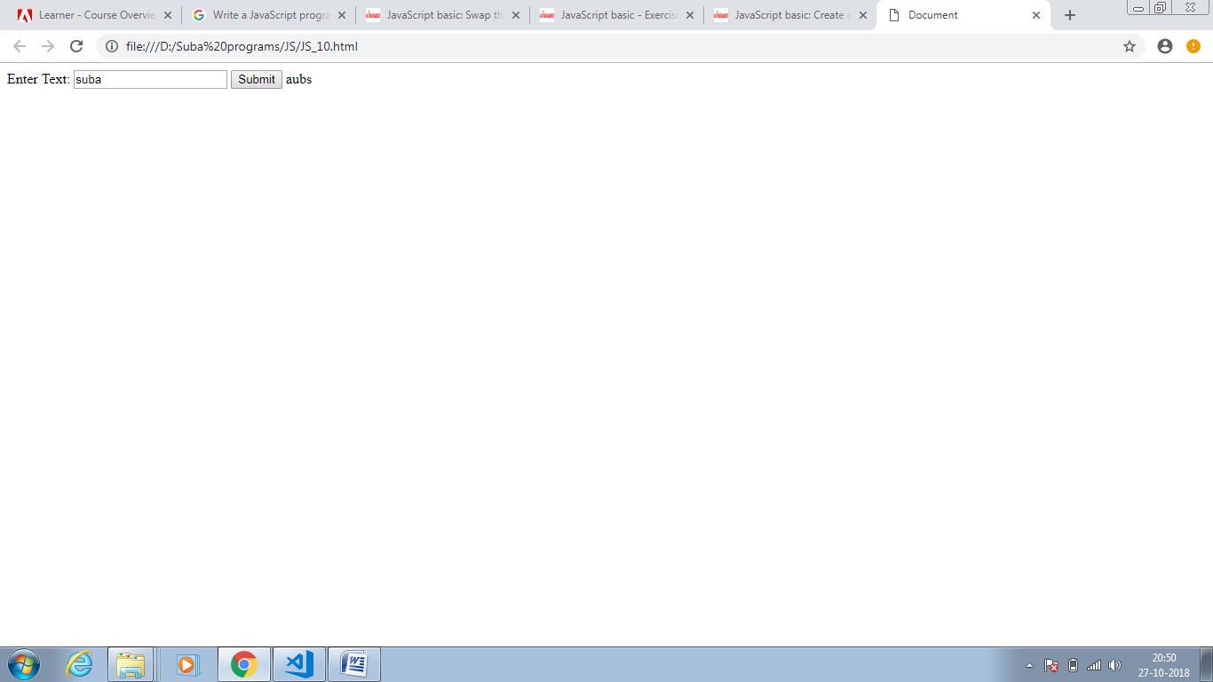

JS_11:

<!DOCTYPE html>

<html lang="en">

<head>

<meta charset="UTF-8">

<meta name="viewport" content="width=device-width, initial-scale=1.0">

<meta http-equiv="X-UA-Compatible" content="ie=edge">

<title>Document</title>

</head>

<body>

Enter Text: <input id = "txtstring" type="text"/>

<button id="btnSubmit" onclick="Reverse()">Submit</button>

<span id="Result"></span>

</body>

</html>

<script>

function Reverse()

{

var inpt = document.getElementById("txtstring").value;

if(inpt.length >= 1)

{

var result = inpt+"";

document.getElementById("Result").innerHTML = result.split("").reverse().join("");

}

else{

document.getElementById("Result").innerHTML = "false";

}

}

</script>

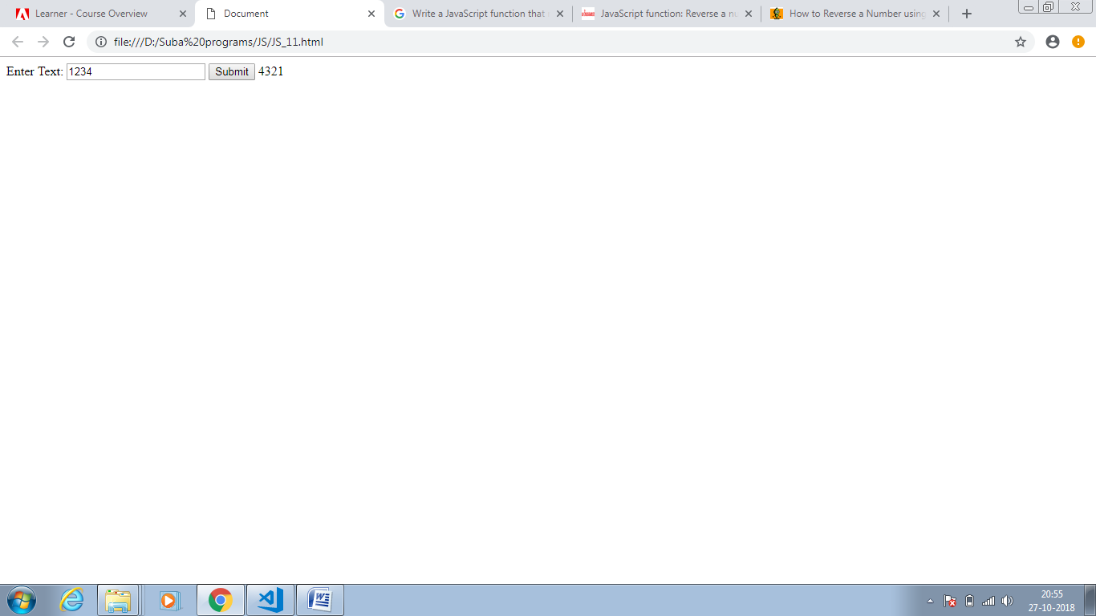

JS_12:

<!DOCTYPE html>

<html lang="en">

<head>

<meta charset="UTF-8">

<meta name="viewport" content="width=device-width, initial-scale=1.0">

<meta http-equiv="X-UA-Compatible" content="ie=edge">

<title>Document</title>

</head>

<body>

Enter Text: <input id = "txtstring" type="text"/>

<button id="btnSubmit" onclick="sort()">Submit</button>

<span id="Result"></span>

</body>

</html>

<script>

function sort()

{

var inpt = document.getElementById("txtstring").value;

if(inpt.length >= 1)

{

var result = inpt+"";

document.getElementById("Result").innerHTML = result.split("").sort().join("");

}

else{

document.getElementById("Result").innerHTML = "false";

}

}

</script>

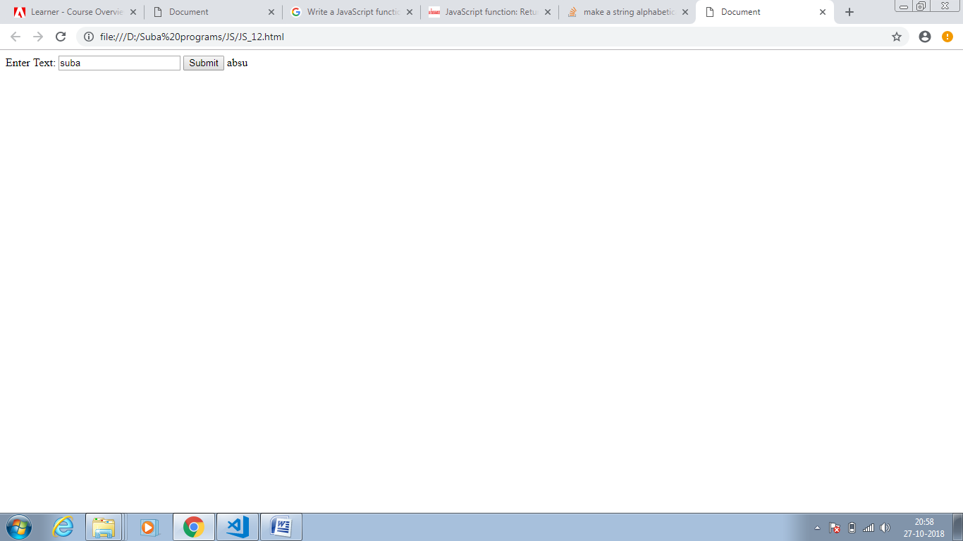

JS_13:

<!DOCTYPE html>

<html lang="en">

<head>

<meta charset="UTF-8">

<meta name="viewport" content="width=device-width, initial-scale=1.0">

<meta http-equiv="X-UA-Compatible" content="ie=edge">

<title>Document</title>

</head>

<body>

Enter Text for longest word: <input id = "txtstring1" type="text"/>

<button id="btnSubmit1" onclick="longest_word()">Submit</button>

<span id="Result1"></span>

<br/>

<br/>

Enter Text for get unique word: <input id = "txtstring2" type="text"/>

<button id="btnSubmit2" onclick="unique_word()">Submit</button>

<span id="Result2"></span>

<br/>

<br/>

Enter Text for get no of occurance word: <input id = "txtstring3" type="text"/>

<button id="btnSubmit3" onclick="occurance_word()">Submit</button>

<span id="Result3"> view console</span>

</body>

</html>

<script>

function longest_word()

{

var inpt = document.getElementById("txtstring1").value;

if(inpt.length >= 1)

{

var array1 = inpt.match(/\w[a-z]{0,}/gi);

var result = array1[0];

for(var x = 1 ; x < array1.length ; x++)

{

if(result.length < array1[x].length)

{

result = array1[x];

}

}

document.getElementById("Result1").innerHTML = result;

}

else{

document.getElementById("Result1").innerHTML = "false";

}

}

function unique_word()

{

var inpt2 = document.getElementById("txtstring2").value;

var result1= "";

if(inpt2.length >= 1)

{

for(var x = 1 ; x < inpt2.length ; x++)

{

if(result1.indexOf(inpt2.charAt(x)) == -1)

{

result1 += inpt2[x];

}

}

document.getElementById("Result2").innerHTML = result1;

}

else{

document.getElementById("Result2").innerHTML = "false";

}

}

function occurance_word()

{

var inpt3 = document.getElementById("txtstring3").value;

if(inpt3.length >= 1)

{

var uchars = {};

inpt3.replace(/\S/g, function (l) { uchars[l] = (isNaN(uchars[l]) ? 1 : uchars[l] + 1); });

console.log(uchars) ;

}

else{

console.log("false");

}

}

</script>

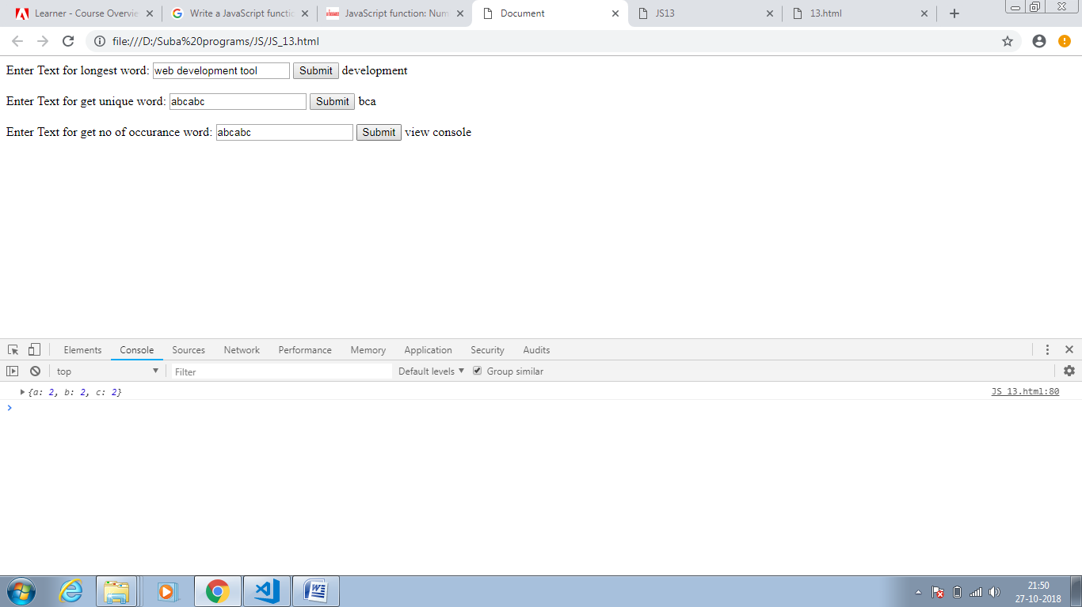

JS_14:

<!DOCTYPE html>

<html lang="en">

<head>

<meta charset="UTF-8">

<meta name="viewport" content="width=device-width, initial-scale=1.0">

<meta http-equiv="X-UA-Compatible" content="ie=edge">

<title>Document</title>

</head>

<body>

Enter length : <input id = "txtlength" type="text"/>

<button id="btnSubmit1" onclick="random_char()">Submit</button>

<span id="Result1"></span>

</body>

</html>

<script>

function random_char()

{

var inpt = document.getElementById("txtlength").value;

var text = "";

var char_list = "ABCDEFGHIJKLMNOPQRSTUVWXYZabcdefghijklmnopqrstuvwxyz0123456789";

for (var i = 0; i < inpt; i++) {

text += char_list.charAt(Math.floor(Math.random() * char_list.length));

document.getElementById("Result1").innerHTML = text;

}

}

</script>

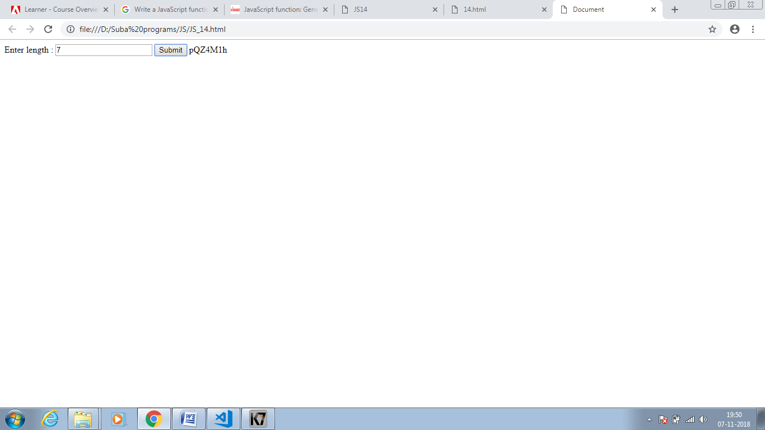

JS_15:

<!DOCTYPE html>

<html lang="en">

<head>

<meta charset="UTF-8">

<meta name="viewport" content="width=device-width, initial-scale=1.0">

<meta http-equiv="X-UA-Compatible" content="ie=edge">

<title>Document</title>

</head>

<body>

Enter text : <input id = "txtString" type="text"/>

<button id="btnSubmit1" onclick="longest_substring()">Submit</button>

<span id="Result1"></span>

</body>

</html>

<script>

function longest_substring(){

var input = document.getElementById("txtString").value;

var chars = input.split('');

var curr_char;

var str = "";

var longest_string = "";

var hash = {};

for (var i = 0; i < chars.length; i++) {

curr_char = chars[i];

if (!hash[chars[i]]) {

str += curr_char;

hash[chars[i]] = { index: i };

}

else {

if (longest_string.length <= str.length) {

longest_string = str;

}

var prev_dupeIndex = hash[curr_char].index;

var str_FromPrevDupe = input.substring(prev_dupeIndex + 1, i);

str = str_FromPrevDupe + curr_char;

hash = {};

for (var j = prev_dupeIndex + 1; j <= i; j++) {

hash[input.charAt(j)] = { index: j };

}

}

}

document.getElementById("Result1").innerHTML = longest_string.length > str.length ? longest_string : str;

}

</script>

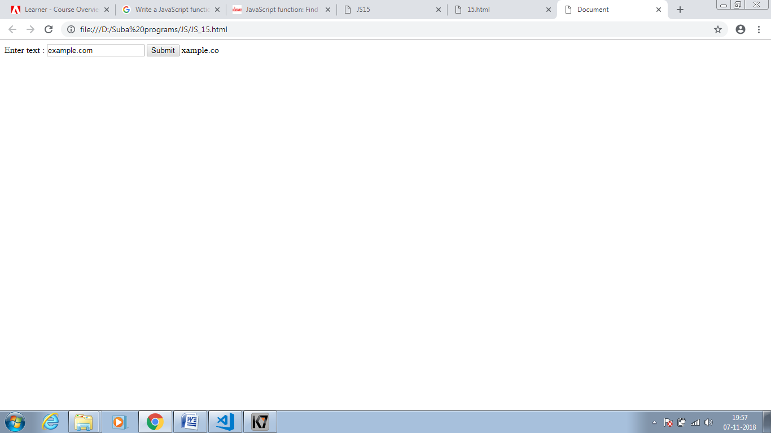

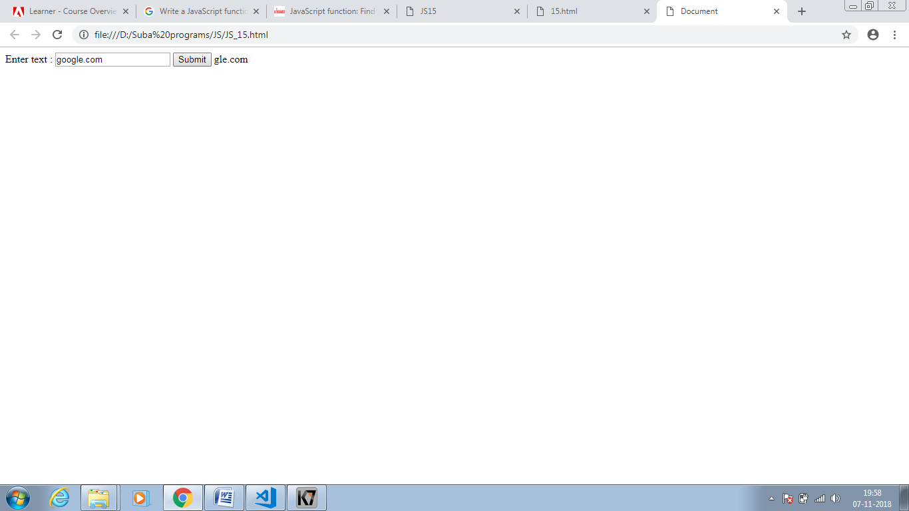

JS_16:

<!DOCTYPE html>

<html>

<head>

<meta charset=utf-8 />

<title>Return first and last name from a form -w3resource</title>

</head>

<body>

<form id="form1" onsubmit="getFormvalue()">

First name: <input type="text" name="fname" value="David"><br>

Last name: <input type="text" name="lname" value="Beckham"><br>

<input type="submit" value="Submit">

</form>

</body>

</html>

<script>

function getFormvalue()

{

var x=document.getElementById("form1");

for (var i=0;i<x.length;i++)

{

if (x.elements[i].value!='Submit')

{

console.log(x.elements[i].value);

}

}

}

</script>

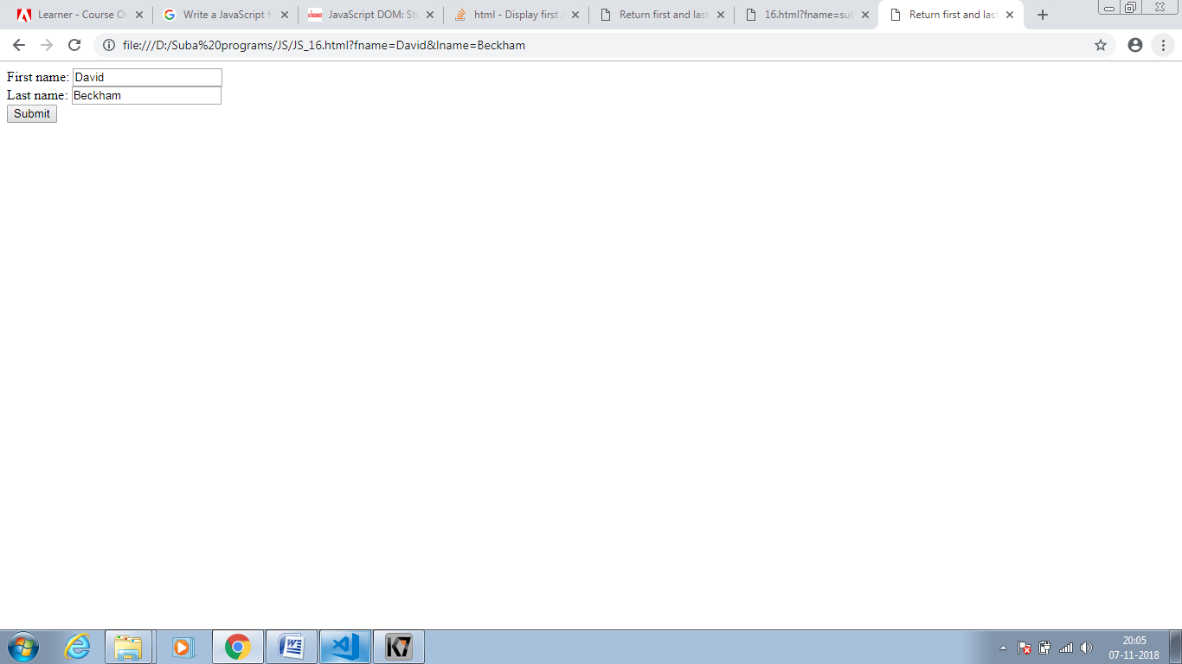

JS_17:

<!DOCTYPE html>

<html>

<head>

<meta charset=utf-8 />

</head>

<body>

<p>

<a id="w3r" type="text/html"hreflang="en-us" rel="nofollow" target="_self" href="https://www.w3resource.com/">w3resource</a>

</p>

<button onclick="getAttributes()">Click here to get attributes value</button>

</body>

</html>

<script>

function getAttributes() {

var u = document.getElementById("w3r").href;

alert('The value of the href attribute of the link is : ' + u);

var v = document.getElementById("w3r").hreflang;

alert('The value of the hreflang attribute of the link is : ' + v);

var w = document.getElementById("w3r").rel;

alert('The value of the rel attribute of the link is : ' + w);

var x = document.getElementById("w3r").target;

alert('The value of the taget attribute of the link is : ' + x);

var y = document.getElementById("w3r").type;

alert('The value of the type attribute of the link is : ' + y);

}

</script>

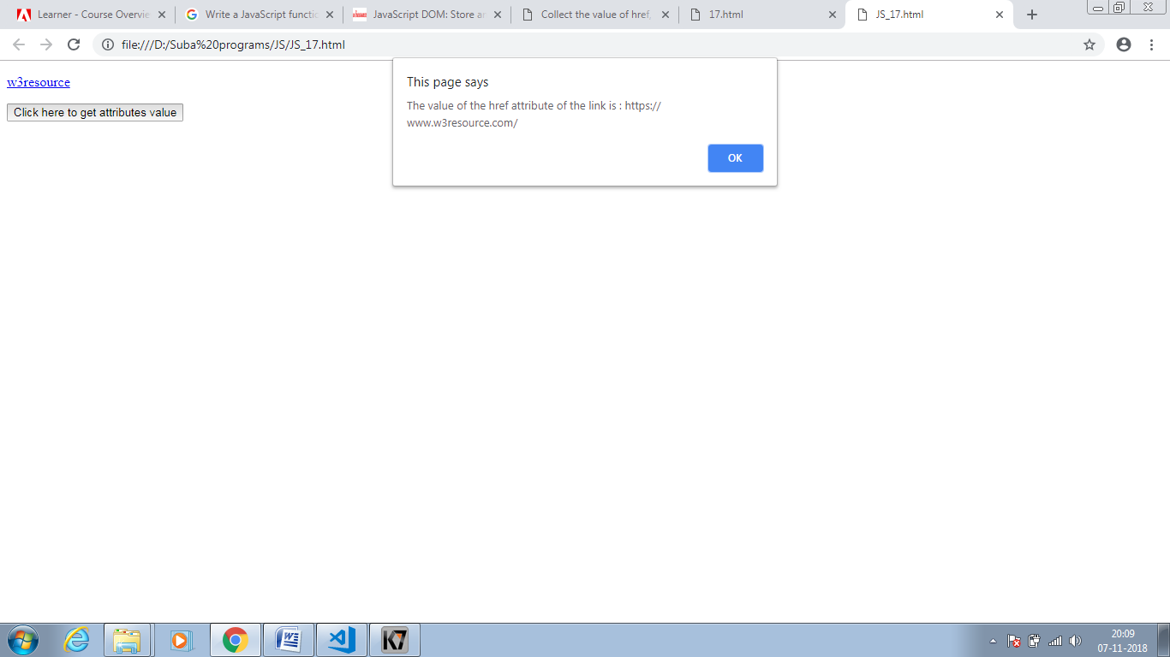

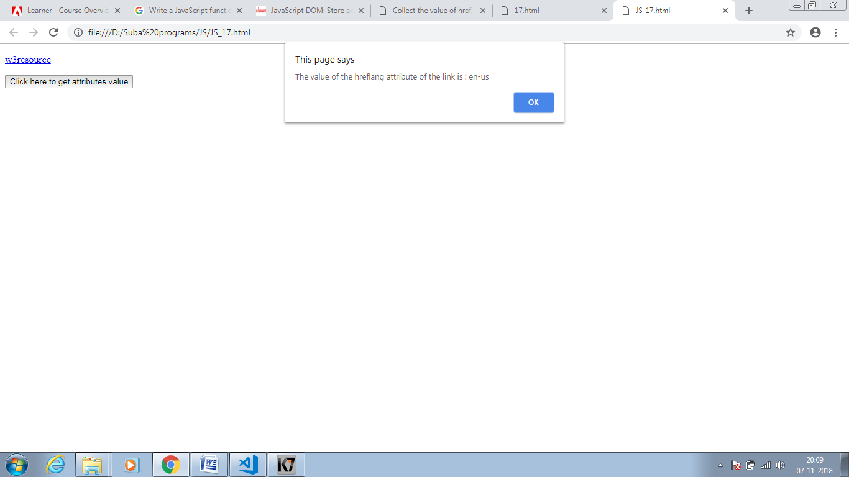

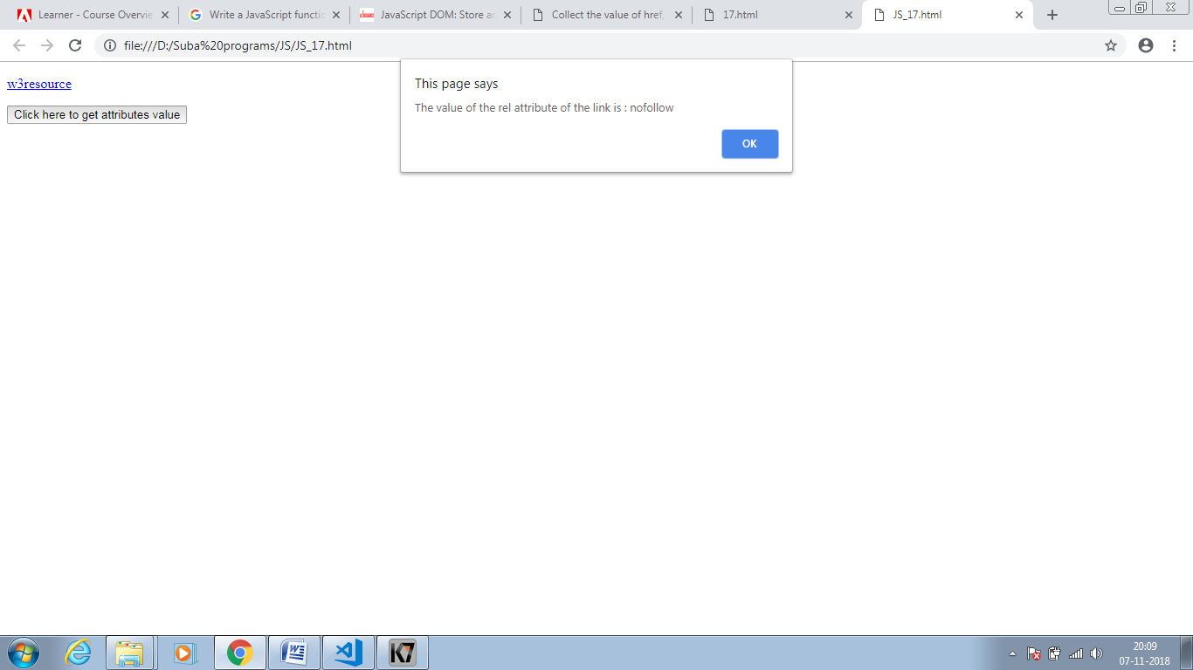

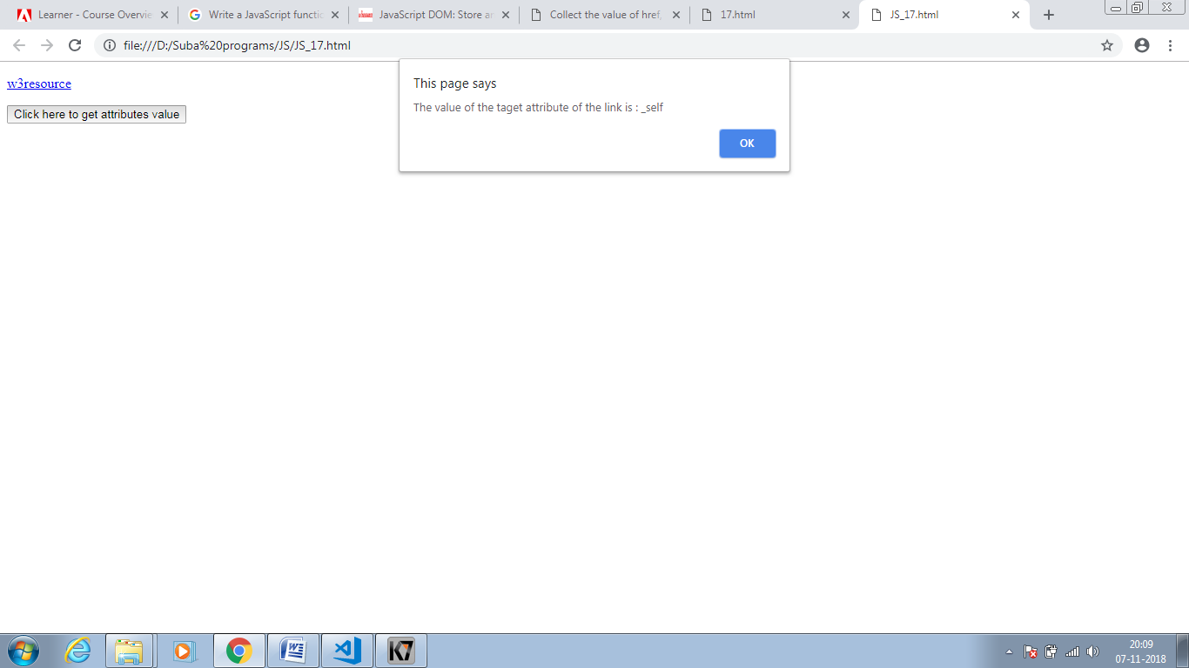

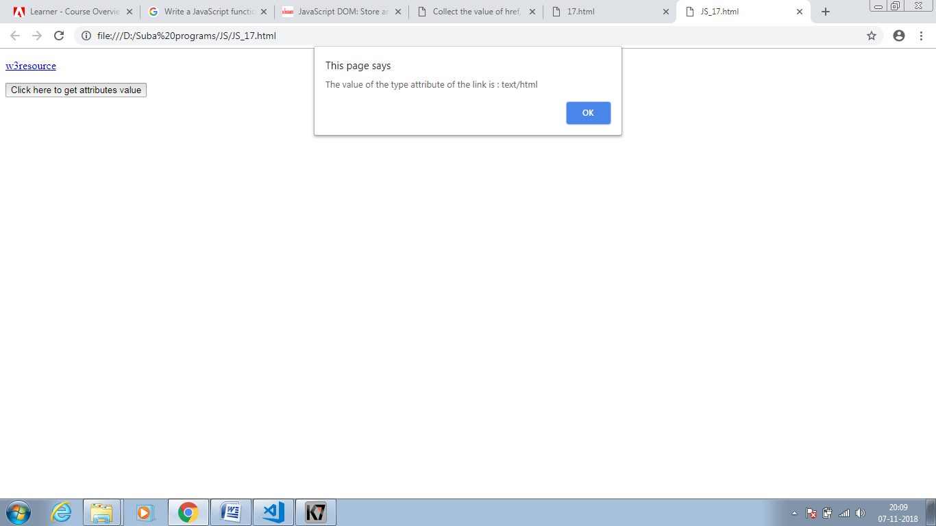

JS_18:

<!DOCTYPE html>

<html>

<head>

<meta charset=utf-8 />

<title>Insert row in a table -w3resource</title>

</head>

<body>

<table id="sampleTable" border="1">

<tr>

<td>Row1 cell1</td>

<td>Row1 cell2</td>

</tr>

<tr>

<td>Row2 cell1</td>

<td>Row2 cell2</td>

</tr>

</table><br>

<input type="button" onclick="insert_Row()" value="Insert row">

</body>

</html>

<script>

function insert_Row() {

var x = document.getElementById('sampleTable').insertRow(0);

var y = x.insertCell(0);

var z = x.insertCell(1);

y.innerHTML = "New Cell1";

z.innerHTML = "New Cell2";

}

</script>

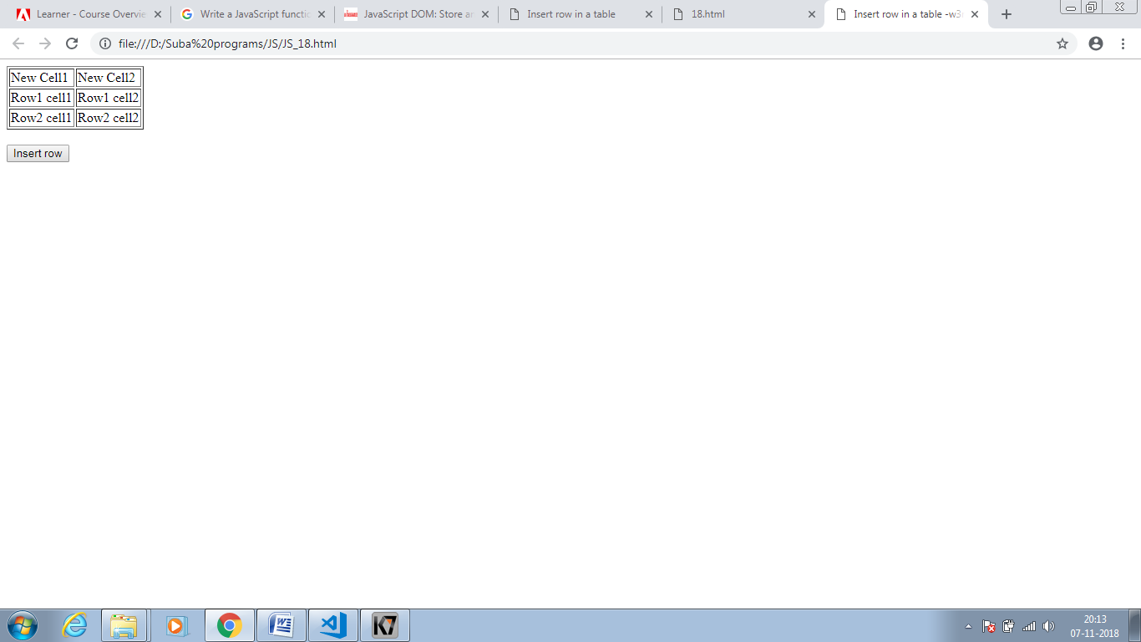

JS_19:

<!DOCTYPE html>

<html>

<head>

<meta charset=utf-8 />

<title>Change the content of a cell</title>

</head>

<body>

<table id="myTable" border="1">

<tr><td>Row1 cell1</td><td>Row1 cell2</td></tr>

<tr><td>Row2 cell1</td><td>Row2 cell2</td></tr>

<tr><td>Row3 cell1</td><td>Row3 cell2</td></tr>

</table>

<form>

<input type="button" onclick="changeContent()" value="Change content">

</form>

</body>

</html>

<script>

function changeContent()

{

rn = window.prompt("Input the Row number(0,1,2)", "0");

cn = window.prompt("Input the Column number(0,1)","0");

content = window.prompt("Input the Cell content");

var x=document.getElementById('myTable').rows[parseInt(rn,10)].cells;

x[parseInt(cn,10)].innerHTML=content;

}

</script>

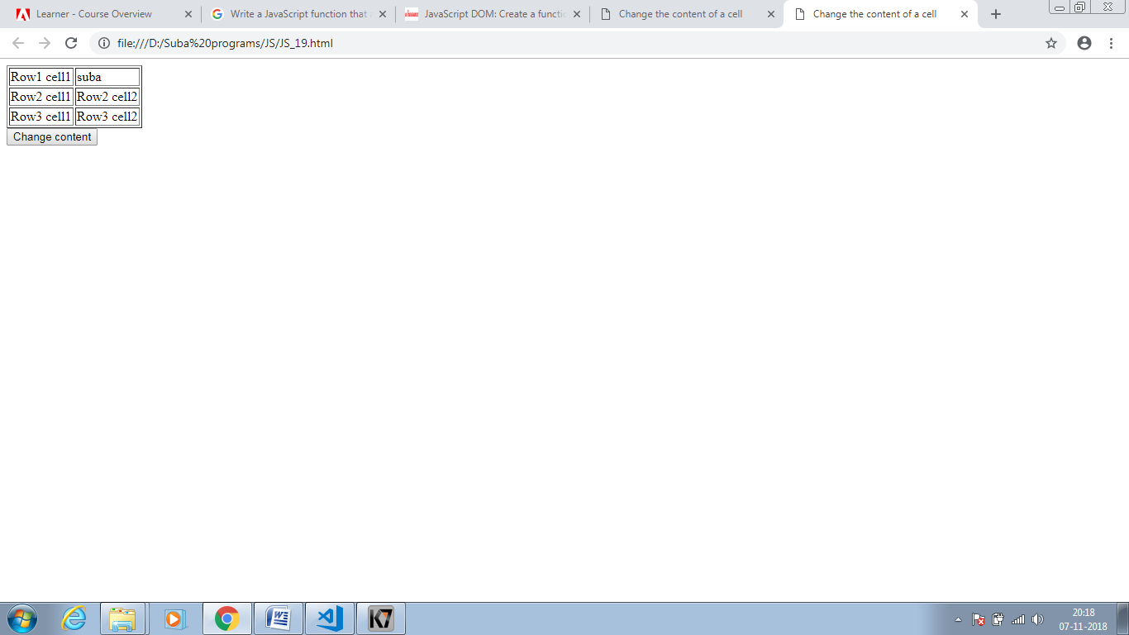

JS_20:

<!DOCTYPE html>

<html>

<head>

<meta charset=utf-8 />

<title>Remove items from a dropdown list</title>

</head>

<body>

<form>

<select id="colorSelect">

<option>Red</option>

<option>Green</option>

<option>White</option>

<option>Black</option>

</select>

<input type="button" onclick="removecolor()" value="Select and Remove">

</form>

</body>

</html>

<script>

function removecolor() {

var x = document.getElementById("colorSelect");

x.remove(x.selectedIndex);

}

</script>

